*Florida International University*

*School of Computing and Information Sciences*

Software Engineering Focus

Feature Document

User Story ID #329

**Name:** Archive Watch Orders

**Team Member(s):** Darilys Pereira

**Project:** Virtual Roll Call 4.0

**Product Owner(s)**: Jason Cohen

**Mentor(s)**: Juan Caraballo

**Instructor**: Masoud Sadjadi

**User Story Name:**

* Description: **As a** supervisor, **I would like** that watch orders which expiration date is in the past are archived **so that we** keep historical records of all watch orders.

Acceptance Criteria

* Archive Watch Orders by Expiration Date
* Admins and supervisors can see the archived watch orders from Supervisor’s side menu.
* Display relevant fields in a grid.

**Use Case**

* Name: View Archived Watch Orders
* Actor: Supervisor
* Preconditions:

1. System is up and running
2. Administrator has successfully logged into the system.
3. Connection to the database has been established.
4. Watch order exist in the database which expiration date is past current date.

* Description:

1. Supervisor clicks Archived Watch Orders tab in the Supervisor side menu
2. Watch orders which expiration date is older that system date will be listed.
3. Supervisor clicks View Details button to review watch order additional details.

**Use Case Diagram**

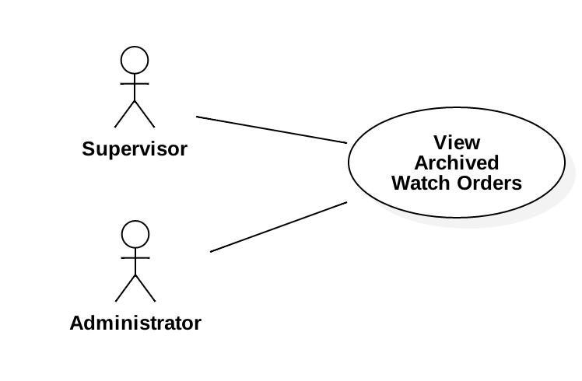

**Sequence Diagram**

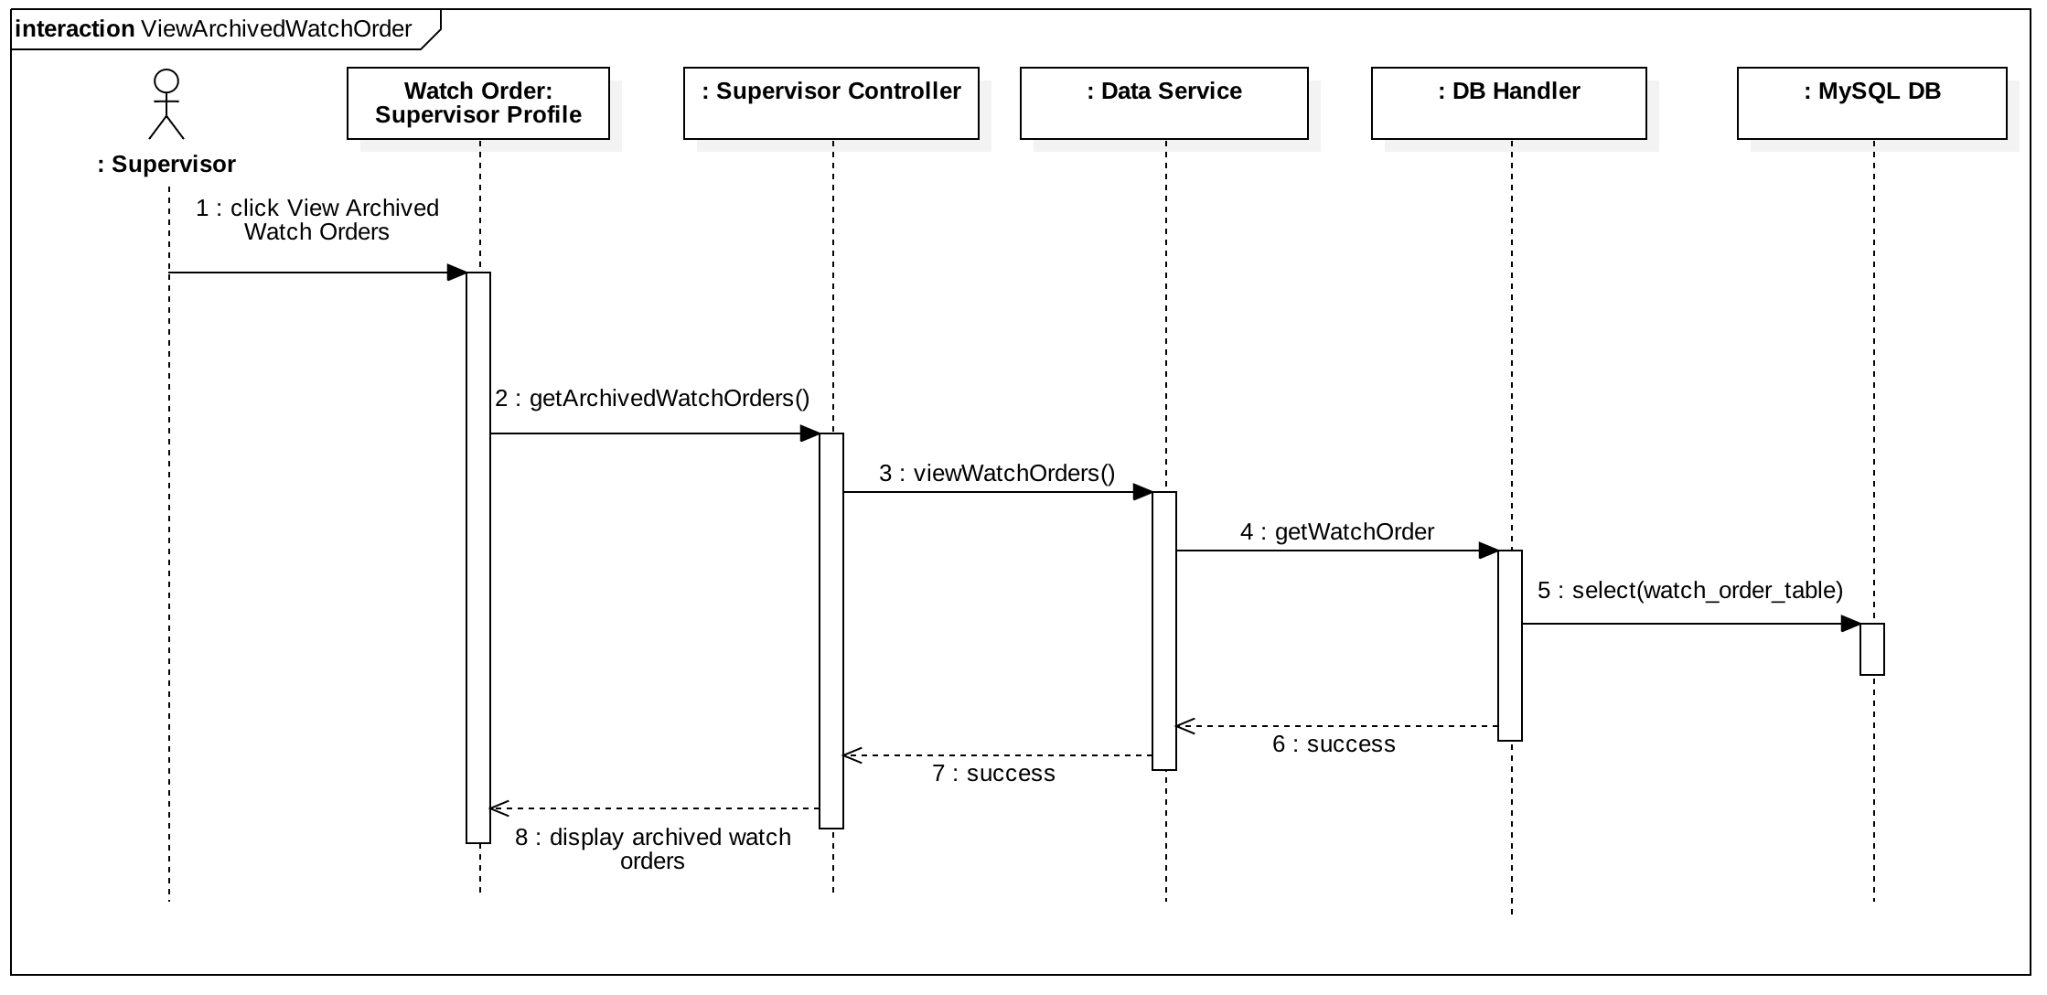

**Class Diagram**

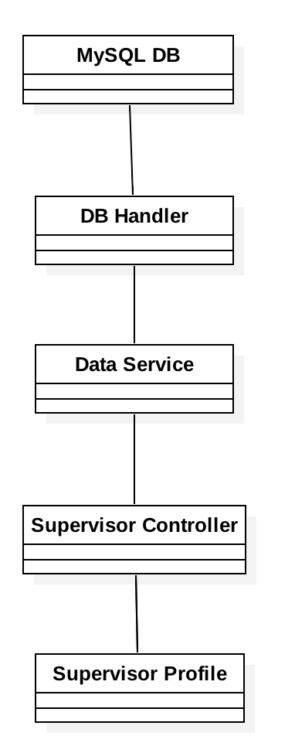

**Unit Test**

* Test case ID: User Story #329 Archive Watch Order
* Description/Summary of Test: Verify that watch orders which expiration date is in the past are listed under the newly created menu “Archived Watch Orders” under Supervisor View.
* Pre-condition:

1. User is logged in.
2. User is in the Archived Watch Order page
3. There are watch orders in database.

* Expected Results: Archived Watch Order table should by populated only with watch orders which expiration date is in the past.
* Actual Result: Tables displayed watch orders with Expiration Date = current day - 1. No future expiration dates were included in the result set.
* Status (Fail/Pass): Passed.

**Integration Test**

Tested system by:

1. Creating new watch orders with expiration date in the past, current date, and future date.
2. Verified results in the Watch order result table.
3. Navigated through the different views of the application verifying existing functionality.
4. Modified existing watch order expiration date from future to past and verified the entry was populated in the result set for archived.

**Visual User Guide**

